Lab Report

Name

Course Code

Institution

Identification of unknown acids by titration
Introduction
It is important to note that chemical reactions are processes between acids and bases. These reactions are used in the synthesis of new substances and can also analyze the pure substance quantity within a mixture compound. In such an experiment, it is essential to determine the base's concentration, which is NaOH, and then use it as a standardized base that will enable the molar mass's determination, which is an unknown weak acid. The molar mass base helps in the conclusion of the identity of the new weak acid. In-water strong acids, produced through the hydronium ions and strong bases constructed through hydroxide ions, the reaction is considered a strong basis in which it is represented through a chemical reaction.
Experiment and Apparatus
Apparatus
Burettes
Pipettes
Volumetric flasks
Stirrers
Burette- the acid-base titrations are used to determine the concentration of a sample of acid and are carried out using this piece of equipment.
Potentiometric titration is a technique that is similar to direct titration of a redox reaction, useful in the characterizing of acid.
The electrode used is calomel and silver-chloride electrodes
Figure 1: Apparatus for potentiometric titration
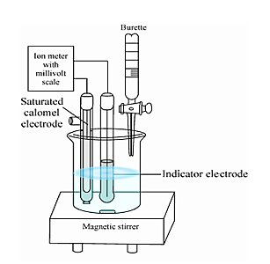

The chemists regard such a reaction to being able to get completed in which reactants are converted into products: H₃ O⁺ + OH⁻ 2H₂O
The reaction between weak acids and strong bases which is represented by equation 2
HA + OH⁻ H₂ O + A⁻
The reaction also goes into completion, and in this experiment, one will use the response in equation 2 to determine the molar concentration of the strong base NaOH using the weak, monoprotic acid potassium hydrogen phthalate (KHP) whereby P⁻ is the phthalate group (Bhukdee, & Limpanuparb, 2020).
HP⁻ + OH⁻ P² + H₂O
The method of analysis will be a titration as a cod with a base. In the first of the experiment, one will standardize in determining the exact concentration of the sodium hydroxide solution; one will determine the concentration through titrating in a known mass known as an acid with a sodium hydroxide solution. Therefore using an acid-base indicator and will be able to find an endpoint of the titration.
Theory
The experiments aimed at determining the molar mass of an unknown acid titrating the acid solution against a solution of NaOH will be considered as molarity calculated based on titration of NaOH solution against the KHP solution. The data collected will allow the analysis of the titration process through the calculations based on titrations. The NaOH solution will be added through the burette to a flask containing the KHP solution (Cui et al., 2017). The experimenters measured the mass of solids will have a volume of NaOH solution used in the titration process to determine molarity. Analysis of the molar mass of the unknown acid reveals the differences based on the possible natures of the acid itself that is considered to be specifically with many protons that donate in the solution; therefore if the acid is monophonic, then the molar mass calculated will be 58,94g/mol, 117.9g/mol if diprotic.
Presentation of Data
A standardization of dilute NaOH solution
Trial 1 Trial 2
Mass of potassium hydrogen phthalate (g) 0.03555 0.3545
Moles of potassium, hydrogen phthalate (moles) 0.001714 0.001736
Volume of NaOH added (mL) 17.46 17.20
Molarity of NaOH solution (M) 0.09971 0.1009
Average molarity of NaOH solution (M) 1.003
%difference between the 2 readings (%) 1.2
B: Molar mass determination
Trial 1 Trial 2
Mass of unknown acid sample (g) 0.1038 0.1038
Volume of NaOH used (mL) 17.56 17.68
Moles of NaOH used (moles) 0.001761 0.001773
Molar mass of acid if monoprotic (g) 58.94 58.54
Average molar mass (g) 58.74
Moles of NaOH
M= moles/L
M=0.001741 moles NaOH (same as moles KHP bc 1 – 1 ratio)
0.01246L NaOH solution = 0.09971M
Moles of NaOH M=moles/L
0.1003M = x/0.01756L
X=0.001761 moles NaOH
Molar mass of acid
HX + NaOH = H₂O + NaX
0.001761mol NaOH x 1 mol acid/1mol base= 0.001761 moles acid
0.1038 g acid/ 0.001761 mol acid =58.94g/mol

Results
The equivalence point describes the stoichiometric amount as the titrant, which was added in an analyte; the endpoint then occurs with the reaction as the titration is observed after it happened (Kinani, Bouchonnet, & Kinani, 2018). The difference between these two points is the lab's systematic error because of the human imperfection in the observation; the equivalence point is where the titration is stopped, resulting in a technically perfect titration. However, the reaction can only be observed at the endpoint with an impossible titration equivalent to an issue regardless of the scientist's performance in the lab. The systematic error is then presented through an observation process. Every experimenter is analyzed through a titration that is considered to be slightly different and cannot entirely stop titrating through a process with specific ideal results.
Table 1: Unknown potentiometric Acid Titration
49.03 |  | 12.4
49.03 |  | 12.36
49.03 |  | 12.31
49.03 |  | 12.26
49.03 |  | 12.19
49.03 |  | 12.05
49.03 |  | 11.99
49.03 |  | 11.91
49.03 |  | 11.75
49.03 |  | 11.56
49.03 |  | 11.51
49.03 |  | 11.33
49.03 |  | 11.15
49.03 |  | 10.77
49.03 |  | 9.57
49.03 |  | 6.22
49.03 |  | 5.75
49.03 |  | 5.4
11 |  | 5.09
9.01 |  | 4.79
6 |  | 4.4
2 |  | 3.71
0 |  | 3.16

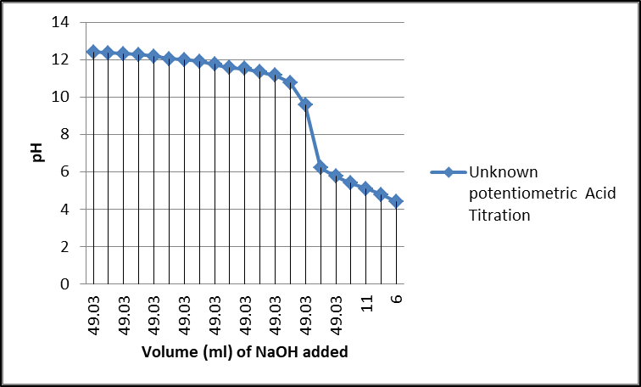

Table 2: Concentration of NaOH and pH of RO water
0 | 2.77
1.98 | 2.98
4.17 | 3.22
6 | 3.42
8 | 3.61
10.83 | 3.81
10.51 | 3.87
11.48 | 3.99
12.53 | 4.13
13.54 | 4.38
13.99 | 4.48
14.48 | 4.62
14.98 | 4.82
15.51 | 4.95
15.78 | 5.12
16.04 | 5.35
16.67 | 5.78
16.99 | 6.95
17.28 | 10.15
17.5 | 10.64
18.01 | 10.89
18.5 | 11.17
19.16 | 11.34
19.54 | 11.47
20.56 | 11.68
22.51 | 12.05
26.52 | 12.13
28.47 | 12.19
30.51 | 13.27
32.55 | 12.39
36.5 | 12.49
38.48 | 12.45
42.52 | 12.27
46.51 | 12.33
49.4 | 12.36

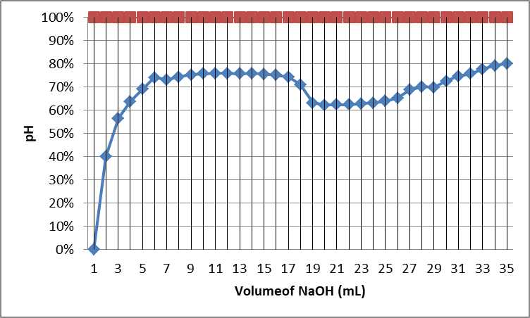

Discussions
It is not possible to determine the unknown acid's chemical formula based on the titration alone (Matilla, Martín‐Mora, & Krell, 2018). The unknown is an acid in which an experimenter is sure that it donates protons. The experiment allows the calculation of the molar mass of the unknown acid, which is useful in determining the chemical formula and through the molar mass, which is based on the assumptions that have three possible molar masses with elements presented in the unknown acid.
Conclusion
The experimenters are prepared and standardized in NaOH's solution then used in a data solution that determines the molar mass of an unknown acid solution by titrating the two solutions together. The nature of the proton donation is new in the experimental results. The monoprotic acid calculation is 58,96g/mol, a diprotic acid is 117.9g/mol, and a tricrotic acid is 176.8 g/mol. The random error was presented in the lab with the impossibility of making perfect measurements, which was prevalent in the titration process; this includes measurements of the volume used in the buret.
Acknowledgments
I want to acknowledge (Name) and chemistry students to participate in this laboratory and provide feedback.

References
Bhukdee, D., & Limpanuparb, T. (2020). Matching Five White Solids to Common Chemicals: A Dissolution Calorimetry and Acid–Base Titration Experiment. Journal of Chemical Education, 97(8), 2356-2361.
Cui, D. S., Beaumont, V., Ginther, P. S., Lipchock, J. M., & Loria, J. P. (2017). Leveraging reciprocity to identify and characterize unknown allosteric sites in protein tyrosine phosphatases. Journal of molecular biology, 429(15), 2360-2372.
Kinani, A., Sa, H., Bouchonnet, S., & Kinani, S. (2018). Determination of adsorbable organic halogens in surface water samples by combustion–microcoulometry versus combustion–ion chromatography titration. Journal of Chromatography A, 1539, 41-52.
Matilla, M. A., Martín‐Mora, D., & Krell, T. (2020). The use of isothermal titration calorimetry to unravel chemotactic signalling mechanisms. Environmental Microbiology.
Thirumalai, M. (2020). Quantitative Estimation of Acid and Base from Locally Available Materials by Using Titration Method. Open Access Library Journal, 7(06), 1.

Figures
- 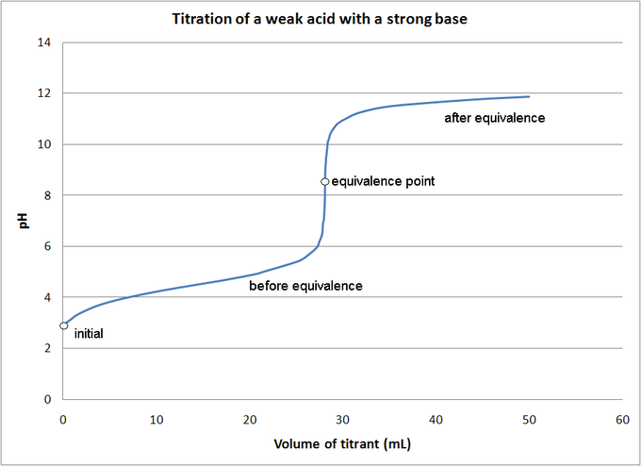
Source: Matilla, M. A., Martín‐Mora, D., & Krell, T. (2020). The use of isothermal titration calorimetry to unravel chemotactic signalling mechanisms. Environmental Microbiology.

- 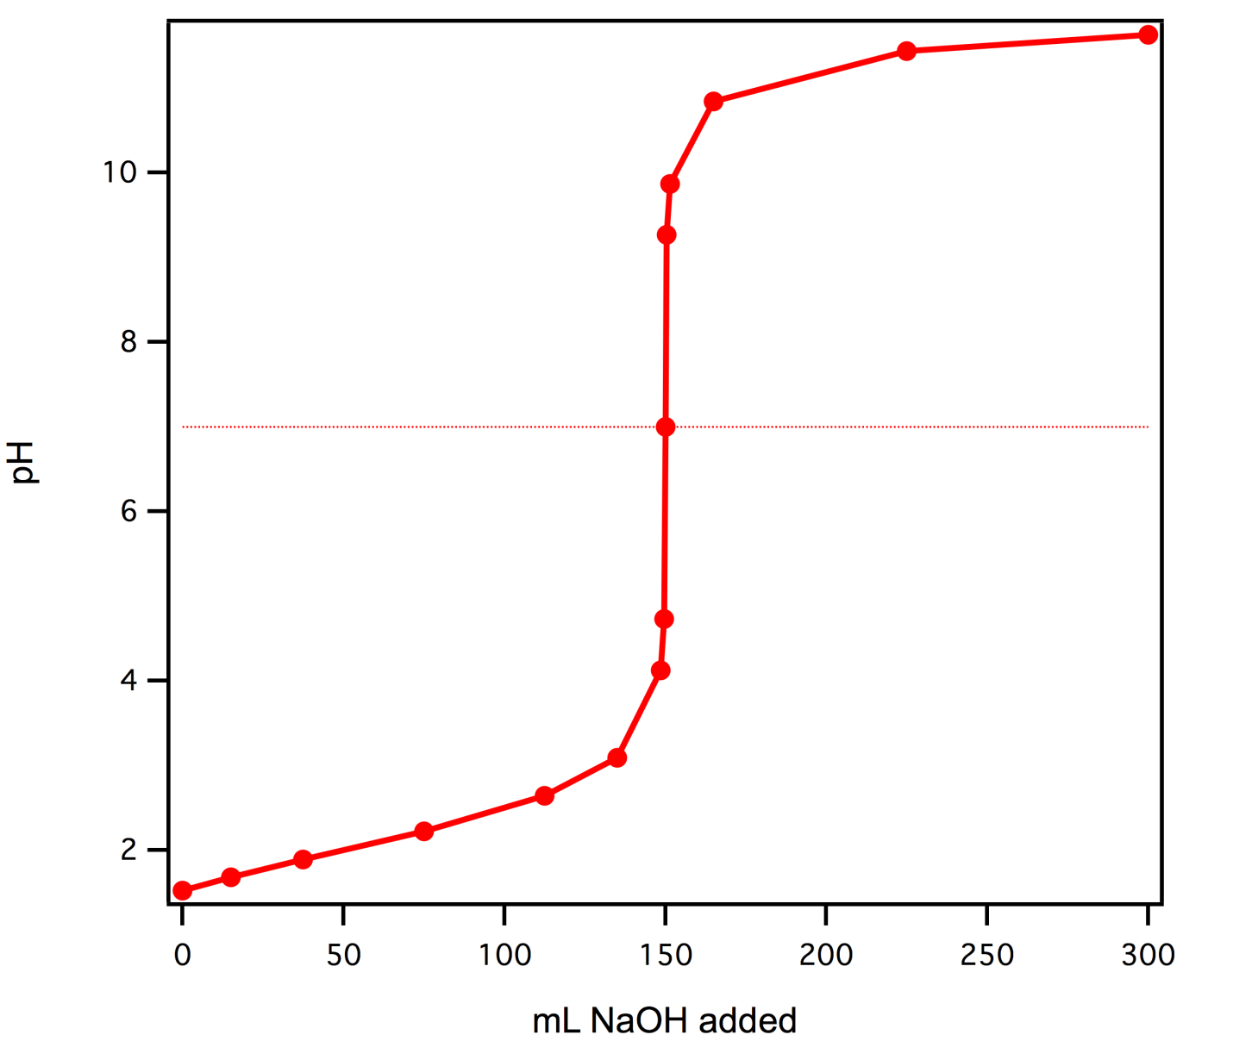
Source: Thirumalai, M. (2020). Quantitative Estimation of Acid and Base from Locally Available Materials by Using Titration Method. Open Access Library Journal, 7(06), 1.

